**Assignment – Data Transform Activity – Josée Gosselin**

**Query 1**

CREATE TABLE employee_sales

(

Attrition string,

Department string,

JobSatisfaction string,

MonthlyIncome int

);

SELECT * FROM employee_sales LIMIT 10;

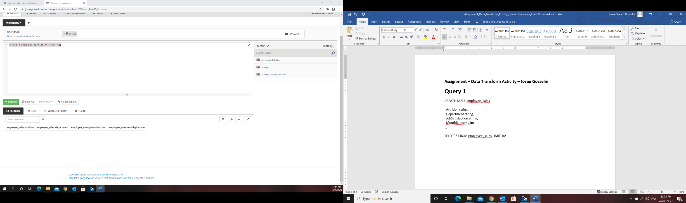

INSERT OVERWRITE TABLE employee_sales

SELECT Attrition, Department, JobSatisfaction, MonthlyIncome

FROM employee;

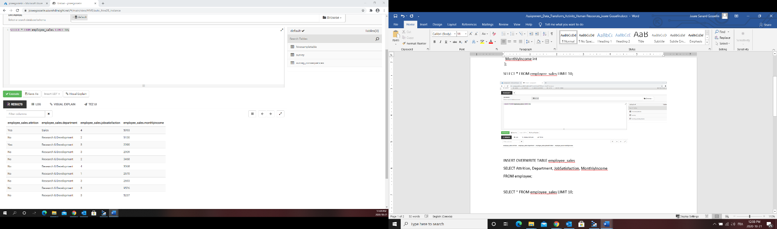SELECT * FROM employee_sales LIMIT 10;

**QUERY 2**

INSERT OVERWRITE TABLE employee_sales

SELECT Attrition, Department, JobSatisfaction, ROUND(MonthlyIncome, -3) AS MonthlyIncome

FROM employee_sales;

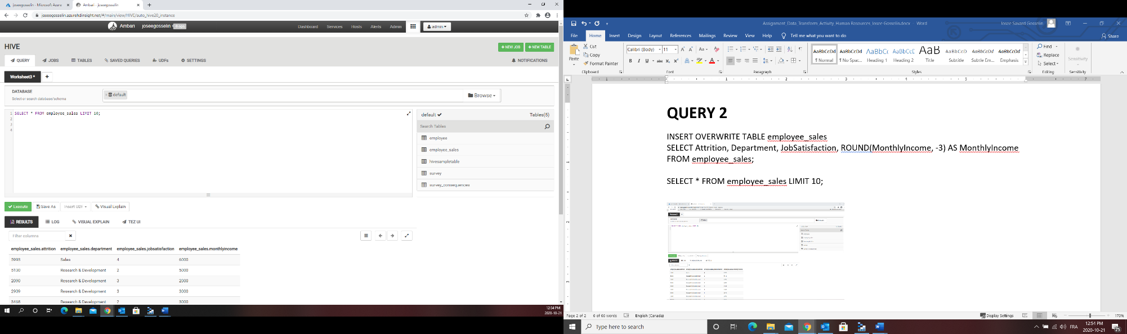SELECT * FROM employee_sales LIMIT 10;

**QUERY 3**

INSERT OVERWRITE TABLE employee_sales

SELECT *

FROM employee_sales

WHERE Department LIKE "%Sales%";

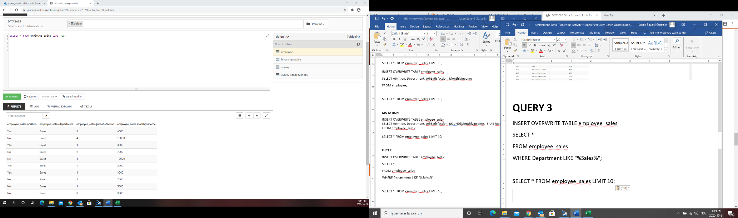SELECT * FROM employee_sales LIMIT 10;

**QUERY 4**

INSERT OVERWRITE TABLE employee_sales

SELECT *

FROM employee_sales

ORDER BY JobSatisfaction DESC;

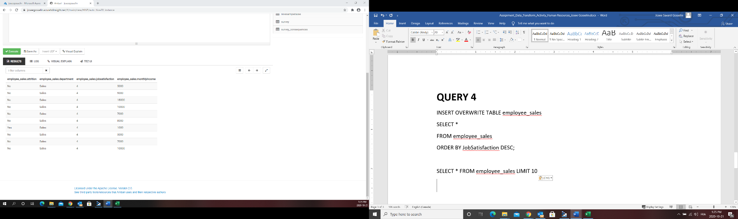SELECT * FROM employee_sales LIMIT 10